|  |  |  |
| --- | --- | --- |
|  | **SRI KRISHNA COLLEGE OF ENGINEERING AND TECHNOLOGY**  (An Autonomous Institution)  (Approved by AICTE and Affiliated to Anna University, Chennai) ACCREDITED BY NAAC WITH “A” GRADE | Description: Description: Description: C:\Documents and Settings\All Users\Documents\My Pictures\Sample Pictures\VLB & Krishna Ins LOGO.jpg |

# **Crime and civil Case Management System**

## A PROJECT REPORT

***Submitted by***

**Vishwa S (19EUIT178)**

**Sreevarshan S (19EUIT161)**

**Sreehari Pranesh K (19EUIT159)**

**Vinith Kumar S (19EUIT176)**

***In partial fulfilment of the requirements for the award of the degree***

***of***

## BACHELOR OF TECHNOLOGY

**in INFORMATION TECHNOLOGY**

## MAY 2022

|  |  |  |
| --- | --- | --- |
|  | **SRI KRISHNA COLLEGE OF ENGINEERING AND TECHNOLOGY**  (An Autonomous Institution)  (Approved by AICTE and Affiliated to Anna University, Chennai)  ACCREDITED BY NAAC WITH “A” GRADE | Description: Description: Description: C:\Documents and Settings\All Users\Documents\My Pictures\Sample Pictures\VLB & Krishna Ins LOGO.jpg |

**BONAFIDE CERTIFICATE**

Certified that this project report **“Crime and Civil Case Management System”** is the bonafide work of “**Vishwa S (19EUIT178), Sreevarshan S (19EUIT161), SreehariPranesh.K(19EUIT122) ,VinithKumar S (19EUIT176)”** who carried out the project work under my supervision.

## SIGNATURE SIGNATURE

Dr.N.SUSILA Dr.V.ANANDKUMAR

## PROFESSOR & HEAD SUPERVISOR

Information Technology Information Technology

Sri Krishna College of Sri Krishna College of

Engg & Tech Engg & Tech

Coimbatore - 641008 Coimbatore – 641008

This project report is submitted for the autonomous project viva-voice examination held on ………………

**INTERNAL EXAMINER EXTERNAL EXAMINER**

# **ACKNOWLEDGEMENT**

At this juncture, we take the opportunity to convey our sincere thanks and gratitude to the management of the college for providing all the facilities to us. We wish to convey our gratitude to our college principal, **Dr. J. Janet**, for forwarding us to do our project and offering adequate duration to complete our project.

We would like to express our grateful thanks to **Dr. N. Susila**, Professor, Head of the Department, Department of Information Technology for her encouragement and valuable guidance to this project.

We extend our gratitude to our beloved class advisor **Mr. M. Ratheeshkumar**, Assistant Professor, Department of Information Technology for his constant support and immense help at all stages of the project.

I am grateful to my project guide **Dr. V. Anandkumar**, Professor, Department of Information Technology for his contributions of time, ideas to our project. We are also grateful for the internal & external members of the project viva voce.

**ABSTRACT**

Access to justice has become an important issue in many justice systems around the world. Increasingly, technology is seen as a potential facilitator of access to justice, particularly in terms of improving justice sector efficiency. The major functionalities covered in court works are registration, indexing and follow up of cases. Case management is the key success factor in judicial system. It also reflects the good image in judiciary. This project is about Crime and civil Case Management System which is developed to make the functional areas in Judicial Service more efficiency and effective. The lawyers play an important role in case Management system and it’s difficult to maintain all the cases .This process involves a lot of paper work , which is not effective in today’s digital world. This case management completely eliminates paper work and maintains all the case records digitally. The lawyer can register a case , update a case , enter billing details for a particular case and set hearing dates for a case through a software. The client can view his / her current case details without contacting the lawyer through this software. This project covers cases which are only related to crime and civil .This project offers easy tracking of cases and view cases in an efficient way. This offers good communication between client and the lawyer .The 21st century has witnessed so many great inventions in science and technology that have led with great potential to solve existing problems.

**List of figures :**

**List of symbols :**

## LIST OF ABBREVIATIONS

**ACRONYMS ABBREVIATIONS**

PHP HyperTextPreprocessor

HTML Hypertext Markup Language

CSS Cascading Style Sheets

**CHAPTER 1**

**INTRODUCTION**

**1.1 OVERVIEW :**

This software is meant to be used by Lawyers or Advocates. This is very powerful software. Any client (Lawyer) who is using this software does not need to worry about maintaining any paperwork.

This software would maintain everything which an advocate needs to do. This software will store the data about the advocate’s client, opponents, Case no., case details, Previous hearing date, next hearing date, court name, employee details, case-related documents. This software is secure to store data.

This software makes it easy to search about the case or case details using the search option. You can search by case no., next hearing date, client, or employee (junior advocate). The software would also manage the day-to-day meetings, appointments.

This system will notify the user of appointments, meetings. The client can search for advocates, view their profiles, and book their slot if available. If an advocate is ready to take the case. An advocate can verify it. Then client pays the advance fee using an online payment portal. Finally, Software would help the advocates/lawyers in maintaining their offices.

Online court case management system is a useful software which can be used by the lawyers , for easier management of client’s cases. It includes registering a case , updating a case , deleting a case , Setting hearing dates ,etc…

**1.2 LITERATURE SURVEY**

**1.2.1 ELECTRONIC COURT CASE MANAGEMENT SYSTEM**

**AUTHORS :** LAUD-RANDY-AMOFAH

**Abstract :**

This project is about Electronic Court Case Management System (eCCMS) which is developed to make the functional areas in Judicial Service more efficiency and effective. One of the main intension of this project is to control and allow complete registration of all court cases and tracking of case current status and location; to enhance public access avoiding client to go to court and also needs to follow up daily after filing of case. This study also considers the adoption of the case management system as an important component in the delivery of service to their clients. The methodology I used for the project development is the Agile Development Methodology. This methodology was used because the project is needed to deal directly with the clients and users so that we the developers will know what they really want and how they want the system to function from the feedback they give after each iteration. The 21st century has witnessed so many great inventions in science and technology that have led with great potential to solve existing problems.

**1.3 OBJECTIVE :**

Case management is a comprehensive system of management of time and events in a law-suit as it proceeds through the justice system, from initiation to resolution. The two essential components of case-management system are the setting of a time table for predetermined events and suspension of the progress of the law-suit through its time-table.

The terms legal case management (LCM), matter management or legal projectmanagement refer to a subset of [law](https://en.wikipedia.org/wiki/Law) practice management and cover a range of approaches

Objective of case management system includes easier maintainance of case and the histories

* Provides easier communication between client and the lawyer .
* The greatest advantage of CMS is to it reduces the paper work.
* Case verdict , hearing dates and priorities can be easily updated.
* Client need not come to lawyer’s office
* Case details can be shared through this software
* Lawyers can easily share the case details without any big effort
* Reports can be generated easily
* Multiple cases can be handled simultaneously
* Easy Sharing of documents , reports , files .
* To develop friendly user interfaces combined with intuitive layouts.
* To create a database to store, manage and backup case records
* To create an administrator page that will show statistical analysis
* Provide just and timely resolution
* Eliminate or reduce undue delay
* Eliminate unnecessary expense
* Meet the different needs of each case
* Make litigation procedures predictable
* Sustain and enhance public confidence

**1.4 FUNCTIONAL REQUIREMENTS**

The functional requirement describe how the system will work in terms of its inputs, the behavior, and outputs. The functional requirements of the system for users are:

* **Login Module:** This shall be developed to have a centralized rights and authentication facility to ensure only authorized users have access to the system providing a security standard to protect vital information.
* **Adding and Removing Cases:** This will provide the registrar the authority to add new cases and to terminate cases if they pass away.
* **A Database Facility**: This shall be developed to store, record, information about users, (date, suit number, plaintiff, defendant, judge etc.)
* **Edit or Update Module:** This shall be developed to ensure easy corrections of mistakes.

**Chapter 2**

**SYSTEM ANALYSIS**

**2.1 Problem definition :**

In the context , a lawyer who wants to manage his / her client’s case without paper i.e . wants to manage case or track cases through an software. It reduces the paper work , so that the layer can easily update a particular case. CMS gives greater advantage towards communication between the client and the lawyer . Simplifies the process of bill generations which is considered as a tedious task for lawyer’s.

**2.2 WHY PHP ?**

The PHP programming language has been around for over two decades and established itself as a powerful and reliable solution, gaining an army of supporters and admirers. However, we need to acknowledge the elePHPant in the room: this coding language is gradually losing its popularity in favor of more recent and optimized counterparts. Let’s have a look at this technology and list pros and cons of PHP, define its area of use, and compare it with several competitive development tools.

The name PHP stands for Hypertext Preprocessor and denotes a server-side scripting language, which means that the applications written on it run on web servers and do not depend on the web browser. However, over the years, its area of use has shifted, and nowadays the PHP coding language is ranked among the best and most popular programming tools for [web development](https://light-it.net/services/web/) due to its many virtues which will be the focus of this article. It is considered a very effective technology that offers a convenient development process with many additional tools to aid it. In fact, according to the Popularity of Programming Language Index (PYPL), PHP is the [fifth most popular coding language](http://pypl.github.io/PYPL.html) in the world. PHP can actually do anything related to server-side scripting or more popularly known as the backend of a website. For example, PHP can receive data from forms, generate dynamic page content, can work with databases, create sessions, send and receive cookies, send emails etc.

**2.3 ADVANTAGES OF PHP**

The popularity of PHP is the logical result of its numerous advantages, all of which make it a powerful and effective development tool. Below is the short list of reasons why PHP is a great choice for your web app, which will be subsequently described in more detail.

9 reasons for using PHP:

* many available specialists;
* a large base of reference and educational materials;
* better loading speed of websites;
* more options for database connectivity;
* a large collection of open-source addons;
* inexpensive website hosting;
* great synergy with HTML;
* excellent flexibility and combinability;
* various benefits provided by cloud solutions.

**1. Improved loading speed**

The use of PHP makes website pages load faster as compared to many other web development technologies. For example, currently, PHP is about three times faster than Python for most use scenarios. In its turn, lower loading time is an important SEO ranking factor that helps further promote a website by bringing competitive advantages. A higher application speed keeps customers satisfied and, in combination with other advantages, helps build and retain the client base.

**2 Wide selection of databases**

PHP allows connection to almost any type of database. The most common choice is MySQL, mainly because it is free, effective, and popular among developers. Other solid options of database management systems compatible with PHP are mSQL, MS-SQL, SQLite, PostgreSQL, etc. Besides, PHP can be equally well used with ElasticSearch, Redis, MongoDB, and other non-relational databases. This way, the developers are not limited to using a particular database and may select the most optimal one for a future app, taking all relevant factors into consideration.

**3. Cheaper hosting services**

The most common operation scenario for a PHP website is the LAMP stack. It means that a website runs on an Apache HTTP web server deployed on a Linux system, and uses MySQL as a database. All these components are free, and the stack is well-tested, which implies the reduction of required time and funds for development.

**4. Excellent combinability with HTML**

PHP offers embedded HTML programming, which is the reason for the incredible synergy between these two technologies. In most cases, a PHP script does not interfere with the HTML code of a web page but instead completes it while remaining inside the borders defined by <?php ?> tags. And vice versa, if you have built a whole page on PHP, you may integrate an HTML code using a script. In this case, the difference from a traditional HTML page would be the inverted order of opening tags: the PHP tags would precede the HTML tags.

**5. Good flexibility**

Flexibility makes PHP able to effectively combine with many other programming languages so that the software product could use the most effective technology for each particular feature. Moreover, PHP is a cross-platform language, which means that developers may use any primary operating system – Windows, Linux, macOS – to perform coding. Such flexibility greatly facilitates the development process by making it faster and less expensive.

**6. Compatibility with cloud services**

Nowadays, many modern products tend to use cloud computing solutions like Amazon Web Services, for various purposes. Applications written in PHP are supported by different cloud services, such as AWS Lambda, for example. Thus, a PHP application can be deployed on a cloud server and achieve excellent scalability and other beneficial effects. Even more, the area of cloud computing is not monopolized by other coding languages, so PHP has taken its place in such implementations.

**2.4 REASONS FOR USING PHP IN CMS :**

* + PHP offers great support for HTML , such that PHP scripts can be easily placed inside an HTML document. (Great choice for server side scripting).
  + Provides many inbuilt databases such as PHPMYADMIN , etc,…
  + Cheaper hosting services
  + Good loading speed compared to other server side programming languages

**2.5 FEASIBILITY STUDY**

**2.5.1 TECHNICAL FEASIBILITY**

This method is used to evaluate the technical aspects of the proposed system. This can be demonstrated if reliable hardware and software capable of meeting the needs of proposed system. It can be acquired or developed in the required time. This project is technically feasible that satisfies the needs in the required time using the reliable hardware and software.

**2.5.2 OPERATIONAL FEASIBILITY**

This is the willingness and ability of the management, lawyers, clients to

operate and support for a proposed system. This method is used for finding how much

effort goes for training the lawyers and clients for the system, which is to be

developed. This project is operationally feasible because this is easy to operate and

only need little knowledge.

**2.5.3 ECONOMICAL FEASIBILITY**

This is the willingness and ability of the management, lawyers, clients to

operate and support for a proposed system. This method is used for finding how much

effort goes for education and training the students for the system, which is to be

developed. This project is operationally feasible because this is easy to operate and

only need little knowledge

**2.5.4 Behavioural Feasibility**

This is the willingness and ability of the management, students, clients to

operate and support for a proposed system. This method is used for finding how much

effort goes for education and training the end-users for the system, which is to be

developed. This project is operationally feasible because this is easy to operate and

only need little knowledge

**CHAPTER 3**

**SYSTEM REQUIREMENT**

**3.1 HARDWARE REQUIREMENTS:**

* Processor - i3 or i5
* Speed - 1.1 GHz
* RAM - 4gb or 8gb
* Hard Disk - 20 GB
* Floppy Drive - 1.44 MB
* Key Board - Standard Windows Keyboard
* Mouse - Two or Three Button Mouse
* Monitor – SVGA

**3.2 SOFTWARE REQUIREMENTS:**

* OPERATING SYSTEM - Windows 7,8,10,11
* XAMPP SERVER
* Any Browser

PHP is the most popular web backend programming language. A PHP code will run as a web server module or as a command-line interface. To run PHP for the web, you need to install a Web Server like Apache and you also need a database server like [MySQL](https://www.edureka.co/blog/mysql-tutorial/). There are various web servers for running [PHP programs](https://www.edureka.co/blog/php-tutorial-for-beginners/) like WAMP & XAMPP. WAMP server is supported in windows and XAMP is supported in both Windows and Linux.

**3.3XAMPP :**

Xampp is the most popular PHP development environment for Windows, OS X, and Linux platforms. Xampp stands for Cross platform(x), Apache(a), Maria db(m), PHP(p), Pearl(p) which is a software distribution server which makes developer’s work eaiser for testing and deploying by creating a local web server. XAMPP is an abbreviation where ***X stands for Cross-Platform, A stands for Apache, M stands for***[***MYSQL***](https://www.javatpoint.com/mysql-tutorial)***, and the Ps stand for PHP and Perl***, respectively. It is an open-source package of web solutions that includes Apache distribution for many servers and command-line executables along with modules such as Apache server, [MariaDB](https://www.javatpoint.com/mariadb-tutorial), PHP, and Perl.

XAMPP helps a local host or server to test its website and clients via computers and laptops before releasing it to the main server. It is a platform that furnishes a suitable environment to test and verify the working of projects based on Apache, Perl, MySQL database, and PHP through the system of the host itself. Among these technologies, [Perl](https://www.javatpoint.com/perl-tutorial) is a programming language used for web development, [PHP](https://www.javatpoint.com/php-tutorial) is a backend scripting language, and MariaDB is the most vividly used database developed by MySQL. The detailed description of these components is given below.

**COMPONENTS OF XAMPP**

As defined earlier, XAMPP is used to symbolize the classification of solutions for different technologies. It provides a base for testing of projects based on different technologies through a personal server. XAMPP is an abbreviated form of each alphabet representing each of its major components. This collection of software contains a web server named **Apache**, a database management system named **MariaDB** and scripting/ programming languages such as **PHP** and **Perl**. X denotes Cross-platform, which means that it can work on different platforms such as [Windows](https://www.javatpoint.com/windows), [Linux](https://www.javatpoint.com/linux-tutorial), and macOS.

Many other components are also part of this collection of software and are explained below.

1. **Cross-Platform:** Different local systems have different configurations of operating systems installed in it. The component of cross-platform has been included to increase the utility and audience for this package of Apache distributions. It supports various platforms such as packages of Windows, Linus, and MAC OS.
2. **Apache:** It is an HTTP a cross-platform web server. It is used worldwide for delivering web content. The server application has made free for installation and used for the community of developers under the aegis of Apache Software Foundation. The remote server of Apache delivers the requested files, images, and other documents to the user.
3. **MariaDB:** Originally, MySQL DBMS was a part of XAMPP, but now it has been replaced by MariaDB. It is one of the most widely used relational DBMS, developed by MySQL. It offers online services of data storage, manipulation, retrieval, arrangement, and deletion.
4. **PHP:** It is the backend scripting language primarily used for web development. PHP allows users to create dynamic websites and applications. It can be installed on every platform and supports a variety of database management systems. It was implemented using C language. PHP stands for **Hypertext Processor**. It is said to be derived from Personal Home Page tools, which explains its simplicity and functionality.
5. **Perl:** It is a combination of two high-level dynamic languages, namely Perl 5 and Perl 6. Perl can be applied for finding solutions for problems based on system administration, web development, and networking. Perl allows its users to program dynamic web applications. It is very flexible and robust.
6. **phpMyAdmin:** It is a tool used for dealing with MariaDB. Its version 4.0.4 is currently being used in XAMPP. Administration of DBMS is its main role.
7. **OpenSSL:** It is the open-source implementation of the Secure Socket Layer Protocol and Transport Layer Protocol. Presently version 0.9.8 is a part of XAMPP.
8. **XAMPP Control Panel:** It is a panel that helps to operate and regulate upon other components of the XAMPP. Version 3.2.1 is the most recent update. A detailed description of the control panel will be done in the next section of the tutorial.
9. **Webalizer:** It is a Web Analytics software solution used for User logs and provide details about the usage.
10. **Mercury:** It is a mail transport system, and its latest version is 4.62. It is a mail server, which helps to manage the mails across the web.
11. **Tomcat:** Version 7.0.42 is currently being used in XAMPP. It is a servlet based on JAVA to provide JAVA functionalities.
12. **Filezilla:** It is a File Transfer Protocol Server, which supports and eases the transfer operations performed on files. Its recently updated version is 0.9.41.

**PHPMYADMIN**

phpMyAdmin is an open-source software tool introduced on **September 9**, **1998**, which is written in PHP. Basically, it is a third-party tool to manage the tables and data inside the database. phpMyAdmin supports various type of operations on **MariaDB** and **MySQL**. The main purpose of phpMyAdmin is to handle the administration of MySQL over the web.

It is the most popular application for MySQL database management. We can create, update, drop, alter, delete, import, and export MySQL database tables by using this software. phpMyAdmin also supports a wide range of operation like **managing databases, relations, tables, columns, indexes, permissions, and users**, etc., on MySQL and MariaDB. These operations can be performed via user interface, while we still have the ability to execute any SQL statement.

phpMyAdmin is translated into ***72 languages*** and also supports both **RTL** and **LTR languages** so that the wide range of people can easily use this software. We can run MySQL queries, repair, optimized, check tables, and also execute other database management commands. phpMyAdmin can also be used to perform administrative tasks such as **database creation, query execution**.

phpMyAdmin is a **GUI-based application** which is used to manage MySQL database. We can manually create database and table and execute the query on them. It provides a web-based interface and can run on any server. Since it is web-based, so we can access it from any computer.

**FEATURES OF PHPMYADMIN**

phpMyAdmin supports several features that are given below:

* phpMyAdmin can create, alter, browse, and drop databases, views, tables, columns, and indexes.
* It can display multiple results sets through queries and stored procedures.
* phpMyAdmin use stored procedure and queries to display multiple results sets.
* It supports foreign keys and InnoDB tables.
* phpMyAdmin can track the changes done on databases, views, and tables.
* We can also create PDF graphics of our database layout.
* phpMyAdmin can be exported into various formats such as XML, CSV, PDF, ISO/IEC 26300 - OpenDocument Text and Spreadsheet.
* It supports mysqli, which is the improved MySQL extension.
* phpMyAdmin can interact with 80 different languages.
* phpMyAdmin can edit, execute, and bookmark any SQL-statements and even batch-queries.
* By using a set of pre-defined functions, it can transform stored data into any format. **For example** - BLOB-data as image or download-link.

**CHAPTER 4**

**SYSTEM DESIGN**

**4.1 SYSTEM MODELLING**

System model is a conceptual model that show the representation and describes a system. A

system comprises multiple views such as planning, requirement, design, implementation,

deployment, structure, behaviour, input data and output data. To fully

develop the systems, conceptual models and structures such as these were used:

* + Class Diagram
  + Use Case Diagram
  + Entity Relationship Diagram
  + Activity Diagram
  + Architectural Diagram

**4.1.1 SYSTEM MODELLING USING UNIFIED MODELLING LANGUAGE**

Unified Modelling Language (UML) is a language used for visualizing, specifying, constructing and documenting an artifacts of a software intensive development project. UML is a graphical language where graphical notation is used to express the ideas rather than using in a textual notation for modeling system. There are three types of UML namely Structural Modeling, Behavioral Modeling and Architectural Modeling.

**4.2. UML: STRUCTURAL MODELING**

Show the things in a system being modeled. In a more technical term, they show different objects in a system. The structures which were used are: Class Diagram

**4.2.1 Class Diagram**

A class diagram is a type of static structure model (diagram) that describes the structure of a system by showing the system's classes, their attributes, methods, and the relationships between the classes. Attributes identifies the characteristics of a class while methods identify the behavior of it. Relationships are the logical links between classes and can be in different flavors. UML diagrams like activity diagram, sequence diagram can only give the sequence flow of the application, however class diagram is a bit different. It is the most popular UML diagram in the coder community.

The purpose of the class diagram can be summarized as −

* + Analysis and design of the static view of an application.
  + Describe responsibilities of a system.
  + Base for component and deployment diagrams.
  + Forward and reverse engineering.

**4.3 UML: BEHAVIORAL MODELING**

Shows what should happen in a system. They describe how the objects interact with each other to create a functioning system. The structures which were used are:

* Use Case Diagram
* Entity Relationship Diagram
* Activity Diagram

**4.3.1 USE CASE DIAGRAM**

A use case diagram includes a set of use cases (including cases, actors and their relationships) where each use case is a description of the functionality of the system from the user’s perspective. Use case diagrams are used to show the functionality that the system will provide and to show which users will communicate with the system in some ways to use that functionality. Use case diagrams are a set of use cases, actors and their relationships. They represent the use case view of a system. The use diagram would specify and show the following:

**Admin :**

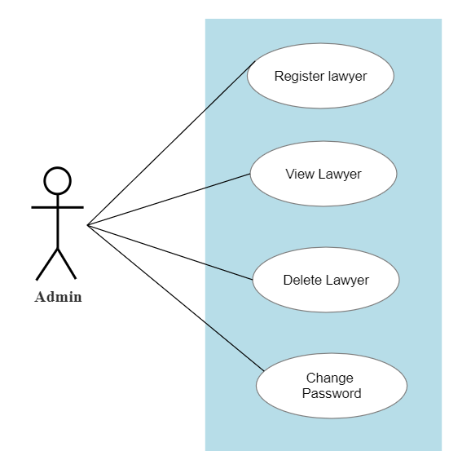

**Lawyer :**

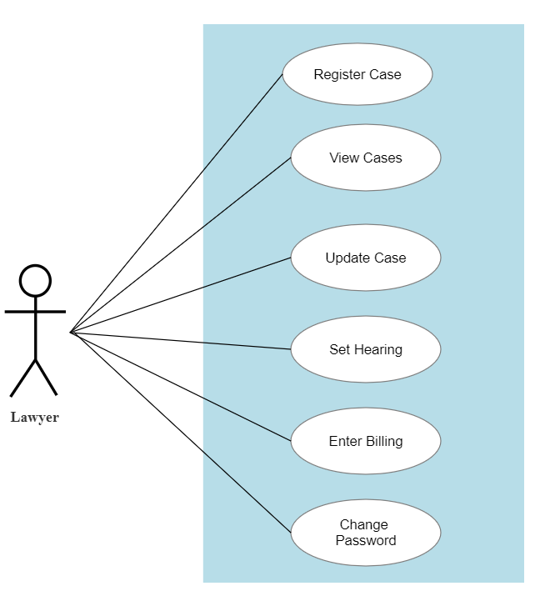

**Client :**

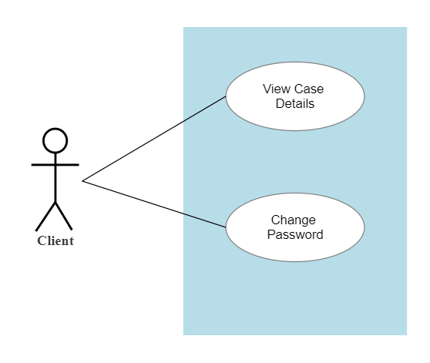

**4.3.2 ENTITY RELATIONSHIP DIAGRAM**

An entity relationship model, also called an entity-relationship (ER) diagram, is a graphical representation of entities and their relationships to each other, typically used in computing in regard to the organization of data within databases or information systems. An entity is a piece of data-an object or concept about which data is stored. ER diagrams are related to data structure diagrams (DSDs), which focus on the relationships of elements within entities instead of relationships between entities themselves. ER diagrams also are often used in conjunction with data flow diagrams (DFDs), which map out the flow of information for processes or systems. It helps you to analyse data requirements systematically to produce a well-designed database. So, it is considered a best practice to complete ER modeling before implementing your database.

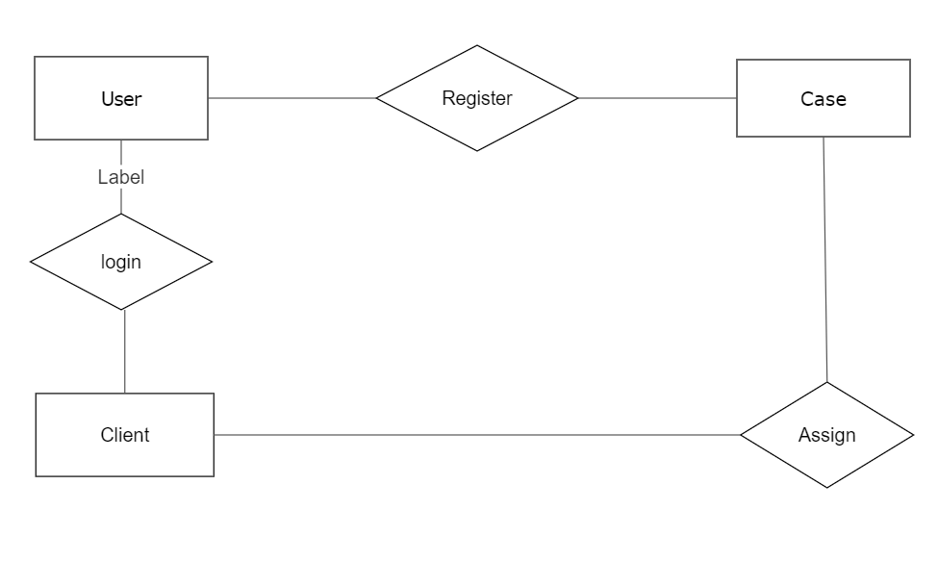

**4.4 FLOW DIAGRAM :**

Flowchart is a graphical representation of an algorithm. Programmers often use it as a program-planning tool to solve a problem. It makes use of symbols which are connected among them to indicate the flow of information and processing.   
The process of drawing a flowchart for an algorithm is known as “flowcharting”.

**Advantages of Flowchart:**

* Flowcharts are a better way of communicating the logic of the system.
* Flowcharts act as a guide for blueprint during program designed.
* Flowcharts help in debugging process.
* With the help of flowcharts programs can be easily analyzed.
* It provides better documentation.
* Flowcharts serve as a good proper documentation.

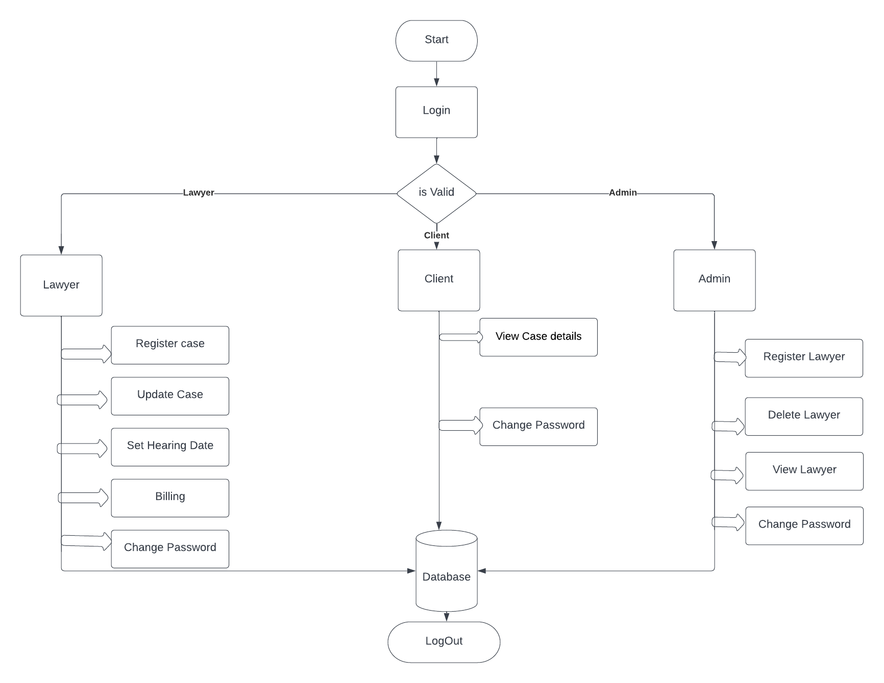

**CHAPTER 5**

**SYSTEM IMPLEMENTATION**

**5.1 DEVELOPMENT TOOLS:**

**Front end :** HTML ,CSS ,BOOTSTRAP

**Back end :** PHP

**Data Base :** PHPMYADMIN(MYSQL)

**Server :** XAMPP

**Text Editor :** Microsoft Visual Studio Code

**5.2 USER INTERFACES :**

**5.2.1 LOGIN PAGE :**

The login page is the page where users enter their credentials for the system to authenticate and ensure only authorized users to access the system providing a security standard to protect vital information. There are three roles – admin , lawyer , client. Session management is used which ensures security in terms of login.

**MODULES :**

The project consists of three modules

* + Admin
  + Lawyer
  + Client

**5.3 ADMIN :**

**REGISTER LAWYER:**

Registering a new Lawyer involves filling :

* + Name
  + Id
  + Licence Number
  + Email id
  + Password
  + Date Of Joining
  + Type

**VIEW LAWYERS :**

Admin can view the list of lawyers in the form of table

* + Id
  + Name
  + Email
  + Licence
  + Employment type
  + Date Of Joining

**DELETE LAWYER :**

Delete lawyer by selecting the particular lawyer id from the drop down list box

**CHANGE PASSWORD :**

Allows admin to change the password

**5.4 LAWYER :**

**REGISTER A CASE :**

The lawyer can register a case by entering the following details :

* Client Id
* Case Id
* Client Name
* Contact Number
* Email
* Case Type
* Case Name

After giving those details , it is saved in the database.

**UPDATE A CASE :**

There are three separate tables exclusively used to track the updates of each case.

* + CASE_HISTORY
  + CASE_VERDICT
  + CASE_STATUS

CASE_HISTORY - Describes about history of case

CASE_VERDICT - Judgement of the case

CASE_STATUS - Pending , next hearing , finished ,…

**SET HEARING DATE FOR A CASE :**

The lawyer can set hearing date by entering the following details :

* + Case Id
  + Hearing date
  + Priority

**ENTER BILLING :**

Bills can be generated by the lawyers by filling the below fields:

* + Client Id
  + Case Id
  + Start Date
  + Billable Hours
  + Rate (Rs/hr)

**CHANGE PASSWORD :**

Change their own password

**5.5 CLIENT :**

* View the current status of their case
* Change the password

**APPENDIX -1**

**Login Page :**

<?php

session_start();

if(isset($_SESSION['logged_in'])){

    if($_SESSION['logged_in']==1)

    {

        header('Location:admin.php');

    }

    elseif ($_SESSION['logged_in']==2)

        header('Location:main.php');

    else

        header('Location:client.php');

}

?>

<!DOCTYPE html>

<html lang="en">

<head>

<meta charset="UTF-8">

<title>Legally Right</title>

<link rel="stylesheet" href="https://maxcdn.bootstrapcdn.com/bootstrap/3.3.0/css/bootstrap.min.css">

<link rel="stylesheet" href="https://maxcdn.bootstrapcdn.com/bootstrap/3.3.0/css/bootstrap-theme.min.css">

<script src="https://ajax.googleapis.com/ajax/libs/jquery/1.11.1/jquery.min.js"></script>

<script src="https://maxcdn.bootstrapcdn.com/bootstrap/3.3.0/js/bootstrap.min.js"></script>

<style type="text/css">

    body{

        padding-top: 70px;

    }

</style>

</head>

<body>

<nav id="myNavbar" class="navbar navbar-default navbar-inverse navbar-fixed-top" role="navigation">

         <!-- Brand and toggle get grouped for better mobile display -->

         <div class="container-fluid">

            <div class="navbar-header">

               <button type="button" class="navbar-toggle" data-toggle="collapse" data-target="#navbarCollapse">

               <span class="sr-only">Toggle navigation</span>

               <span class="icon-bar"></span>

               <span class="icon-bar"></span>

               <span class="icon-bar"></span>

               </button>

               <a class="navbar-brand" href="#">Legally Right | Admin</a>

            </div>

            <!-- Collect the nav links, forms, and other content for toggling -->

            <div class="collapse navbar-collapse" id="navbarCollapse">

               <ul class="nav navbar-nav">

                  <li class="active"><a href="#" >Login</a></li>

                  <li><a href="visitor.php" >Visitors</a></li>

               </ul>

            </div>

         </div>

      </nav>>

</nav>

<div class="container">

    <div class="jumbotron">

        <h3>Welcome!!!</h3>

    </div>

    <div class="control-label col-xs-8">

    <form method="POST" class='form-horizontal' action="login.php">

    <div class='form-group'>

    <label class="control-label col-xs-4">Username/ID: </label><div class="col-xs-8"><input class="form-control" type = "text" name = "username"><br />

    </div></div><div class='form-group'>

    <label class="control-label col-xs-4">Password: </label><div class="col-xs-8"><input class="form-control" type = "password" name = "password"><br />

    </div></div><div class='form-group'>

    <label class="control-label col-xs-4">Type:</label> <div class="col-xs-8"><select class="form-control" name="login_type">

    <option value="admin">Admin</option>

    <option value="lawyer">Lawyer</option>

    <option value="client">Client</option>

    </select><br />

    </div>

    </div>

    <div class = "control-label col-xs-4"></div>

<div class = "control-label col-xs-4"><h4>

<?php

if(isset($_SESSION['a'])){

    unset($_SESSION['a']);

    echo "<script> alert('Login Failed') </script>";

}

    ?>

</h4></div>

<div class = "control-label col-xs-4"></div>

<div class = "control-label col-xs-4">

                     <br />

                     <button type="submit" formaction="login.php" class="btn btn-primary">Login</button>

                     </div>

    </form>

    </div>

    </div>

</body>

</html>

<?php

session_start();

$login = $_POST['login_type'];

$username = $_POST['username'];

$password = $_POST['password'];

require("config.php");

if($login == 'admin'){

$sql = "SELECT username , password FROM ADMIN WHERE username = '$username'";

$value = mysqli_query($conn,$sql);

$row = mysqli_fetch_assoc($value);

if (!mysqli_num_rows($value)){

    $_SESSION['a']=1;

    header('Location:index.php');

}

else {

    if($username != $row['username']){

        $_SESSION['a']=1;

        header('Location:index.php');

    }

    elseif($password != $row['password']){

        $_SESSION['a']=1;

        header('Location:index.php');

    }

    else{

        $_SESSION['logged_in'] = 1;

        $_SESSION['username'] = $username;

        header('Location:admin.php');

    }

}

}

elseif ($login == "lawyer"){

    $sql = "SELECT id,password FROM LAWYER WHERE id = '$username'";

    $value = mysqli_query($conn,$sql);

    $row = mysqli_fetch_assoc($value);

    if (!mysqli_num_rows($value)){

        $_SESSION['a']=1;

        header('Location:index.php');

    }

    else {

        if($username != $row['id']){

            $_SESSION['a']=1;

        header('Location:index.php');

        }

        elseif($password != $row['password']){

            $_SESSION['a']=1;

        header('Location:index.php');

        }

        else{

            $_SESSION['logged_in'] = 2;

            $_SESSION['username'] = $username;

            header('Location:main.php');

        }

    }

}

else{

    $sql = "SELECT id,password,lawyer_id FROM CLIENT WHERE id = '$username'";

    $value = mysqli_query($conn,$sql);

    $row = mysqli_fetch_assoc($value);

    if (!mysqli_num_rows($value)){

        $_SESSION['a']=1;

    }

    else {

        if($username != $row['id']){

            $_SESSION['a']=1;

        header('Location:index.php');

        }

        elseif($password != $row['password']){

            $_SESSION['a']=1;

        header('Location:index.php');

        }

        else{

            $_SESSION['logged_in'] = 3;

            $_SESSION['username'] = $username;

            $_SESSION['lawyer'] = $row['lawyer_id'];

            header('Location:client.php');

        }

    }

}

?>

**Lawyer Page :**

<?php

session_start();

require("config.php");

require("check_login.php");

$columns = ['id','name','email_id','license_no','employment','date_of_joining'];

$numFields = count($columns);

$id = $_SESSION['username'];

$sql = "SELECT * FROM LAWYER WHERE id = '$id'";

$value = mysqli_query($conn,$sql);

?>

<html lang="en">

<head>

<meta charset="UTF-8">

<title>Legally Right | <?php echo $id ;?></title>

<link rel="stylesheet" href="https://maxcdn.bootstrapcdn.com/bootstrap/3.3.0/css/bootstrap.min.css">

<link rel="stylesheet" href="https://maxcdn.bootstrapcdn.com/bootstrap/3.3.0/css/bootstrap-theme.min.css">

<script src="https://ajax.googleapis.com/ajax/libs/jquery/1.11.1/jquery.min.js"></script>

<script src="https://maxcdn.bootstrapcdn.com/bootstrap/3.3.0/js/bootstrap.min.js"></script>

<style type="text/css">

    body{

      padding-top: 70px;

    }

</style>

</head>

<body>

<nav id="myNavbar" class="navbar navbar-default navbar-inverse navbar-fixed-top" role="navigation">

         <!-- Brand and toggle get grouped for better mobile display -->

         <div class="container-fluid">

            <div class="navbar-header">

               <button type="button" class="navbar-toggle" data-toggle="collapse" data-target="#navbarCollapse">

               <span class="sr-only">Toggle navigation</span>

               <span class="icon-bar"></span>

               <span class="icon-bar"></span>

               <span class="icon-bar"></span>

               </button>

               <a class="navbar-brand" href="#">Legally Right | <?php echo $id ;?></a>

            </div>

            <!-- Collect the nav links, forms, and other content for toggling -->

            <div class="collapse navbar-collapse" id="navbarCollapse">

               <ul class="nav navbar-nav">

                  <li class="active"><a href="#" >Home</a></li>

                  <li><a href="view-cases.php">View Cases</a></li>

                  <li><a href="client_register.php" >Register Your Client</a></li>

                  <li><a href="update_case.php" >Update Case Info</a></li>

                  <li><a href="billing.php" >Enter Billing Details</a></li>

                  <li><a href="set_hearing.php">Enter Hearing Date</a></li>

                  <li><a href="update_password.php">Change Password</a></li>

                  <!-- <li><a href="enquiries.php">Your Enquiries</a></li> -->

               </ul>

               <ul class="nav navbar-nav navbar-right">

                <li><a href="logout.php">Logout</a></li>

            </ul>

            </div>

         </div>

      </nav>>

</nav>

<div class="container">

   <div class="jumbotron">

      <h3>Welcome <?php echo $id;?> !!!</h3>

   </div>

   <div class="control-label col-xs-4">

   </div>

   <div class="control-label col-xs-4">

   <ul class="list-group">

<?php

$rows = mysqli_fetch_assoc($value);

   for($i = 0 ; $i < $numFields ; $i++)

      echo "<li class='list-group-item'>".$columns[$i].': '.$rows[$columns[$i]].'</li>';

?>

</ul>

</div>

<div class="control-label col-xs-4">

   </div>

</body>

</html>

**Update case :**

<?php

session_start();

$id = $_SESSION['username'];

require('check_login.php');

require('config.php');

if(isset($_POST['curr_pass'])){

   $password = $_POST['curr_pass'];

   $new_pass = $_POST['new_pass'];

   $re_pass = $_POST['re_pass'];

   if($new_pass != $re_pass){

      unset($_POST['curr_pass']);

      header('Location:update_password.php');

   }

   $sql = "SELECT id,password FROM LAWYER WHERE id = '$id'";

   $value = mysqli_query($conn,$sql);

   echo mysqli_connect_error();

   $row = mysqli_fetch_assoc($value);

   if($row['password'] != $password){

      unset($_POST['curr_pass']);

      header('Location:update_password.php');

   }

   $sql = "UPDATE LAWYER SET password = '$new_pass' WHERE id = '$id'";

   $value = mysqli_query($conn,$sql);

   echo mysqli_connect_error();

}

?>

<!DOCTYPE html>

<html lang="en">

<head>

<meta charset="UTF-8">

<title>Legally Right | <?php echo $id ?></title>

<link rel="stylesheet" href="https://maxcdn.bootstrapcdn.com/bootstrap/3.3.0/css/bootstrap.min.css">

<link rel="stylesheet" href="https://maxcdn.bootstrapcdn.com/bootstrap/3.3.0/css/bootstrap-theme.min.css">

<script src="https://ajax.googleapis.com/ajax/libs/jquery/1.11.1/jquery.min.js"></script>

<script src="https://maxcdn.bootstrapcdn.com/bootstrap/3.3.0/js/bootstrap.min.js"></script>

<style type="text/css">

    body{

      padding-top: 70px;

    }

</style>

</head>

<body>

<nav id="myNavbar" class="navbar navbar-default navbar-inverse navbar-fixed-top" role="navigation">

         <!-- Brand and toggle get grouped for better mobile display -->

         <div class="container-fluid">

            <div class="navbar-header">

               <button type="button" class="navbar-toggle" data-toggle="collapse" data-target="#navbarCollapse">

               <span class="sr-only">Toggle navigation</span>

               <span class="icon-bar"></span>

               <span class="icon-bar"></span>

               <span class="icon-bar"></span>

               </button>

               <a class="navbar-brand" href="#">Legally Right | <?php echo $id ?></a>

           </div>

           <div class="collapse navbar-collapse" id="navbarCollapse">

               <ul class="nav navbar-nav">

                  <li><a href="main.php" >Home</a></li>

                  <li><a href="view-cases.php">View Cases</a></li>

                  <li><a href="client_register.php" >Register Your Client</a></li>

                  <li><a href="update_case.php" >Update Case History</a></li>

                  <li><a href="billing.php" >Enter Billing Details</a></li>

                  <li><a href="set_hearing.php">Enter Hearing Date</a></li>

                  <li class="active"><a href="update_password.php">Change Password</a></li>

               </ul>

               <ul class="nav navbar-nav navbar-right">

                <li><a href="logout.php">Logout</a></li>

            </ul>

            </div>

         </div>

      </nav>>

</nav>

<div class="container">

   <div class="jumbotron">

      <h3>Change your Password</h3>

   </div>

   <div class="control-label col-xs-8">

         <form method="POST" class='form-horizontal' action="<?php $_PHP_SELF ?>">

                  <div class='form-group'>

<label class="control-label col-xs-4">Enter current password:</label><div class="col-xs-8"><input class="form-control" name = 'curr_pass' type = 'password'><br />

</div></div>

<div class='form-group'>

<label class="control-label col-xs-4">Enter new password:</label><div class="col-xs-8"> <input class="form-control" name = 'new_pass' type = 'password'><br />

</div></div><div class='form-group'>

<label class="control-label col-xs-4">Re-enter new password:</label><div class="col-xs-8"> <input class="form-control" name = 're_pass' type = 'password'><br />

</div></div>

<div class = "control-label col-xs-5"></div>

   <div class = "control-label col-xs-2">

   <button type="submit" formaction="<?php $_PHP_SELF ?>" class="btn btn-primary">Submit</button>

   </div>

</form>

</body>

</html>

**VIEW CASES:**

<?php

session_start();

require("config.php");

require('check_login.php');

$l_id = $_SESSION['username'];

$sql = "SELECT id , client_id , type, name  FROM cases where lawyer_id = '$l_id'";

$result = mysqli_query($conn, $sql);

?>

<!DOCTYPE html>

<html>

<head>

    <title>Create</title>

    <link rel="stylesheet" href="https://maxcdn.bootstrapcdn.com/bootstrap/3.3.0/css/bootstrap.min.css">

<link rel="stylesheet" href="https://maxcdn.bootstrapcdn.com/bootstrap/3.3.0/css/bootstrap-theme.min.css">

<script src="https://ajax.googleapis.com/ajax/libs/jquery/1.11.1/jquery.min.js"></script>

<script src="https://maxcdn.bootstrapcdn.com/bootstrap/3.3.0/js/bootstrap.min.js"></script>

    <link rel="stylesheet" href="https://maxcdn.bootstrapcdn.com/bootstrap/4.0.0/css/bootstrap.min.css" integrity="sha384-Gn5384xqQ1aoWXA+058RXPxPg6fy4IWvTNh0E263XmFcJlSAwiGgFAW/dAiS6JXm" crossorigin="anonymous">

    <link rel="stylesheet" href="css/style.css">

    <style>

        .button-create{

            border:20px solid #4394ba;

            border-radius:8px;

            width: 140px;

            height: 30px;

            background-color: #4394ba;

            color: #fff;

        }

        .button-create:hover{

            text-decoration: none;

            background-color: #db2c58;

            border:20px solid #db2c58;

            color: #fff;

        }

        .link-right{

            position: absolute;

            top:50px;

            left:200px;

        }

        .btn{

            width: 80px;

        }

    </style>

</head>

<body>

<nav id="myNavbar" class="navbar navbar-default navbar-inverse navbar-fixed-top" role="navigation">

         <!-- Brand and toggle get grouped for better mobile display -->

         <div class="container-fluid">

            <div class="navbar-header">

               <button type="button" class="navbar-toggle" data-toggle="collapse" data-target="#navbarCollapse">

               <span class="sr-only">Toggle navigation</span>

               <span class="icon-bar"></span>

               <span class="icon-bar"></span>

               <span class="icon-bar"></span>

               </button>

               <a class="navbar-brand" href="#">Legally Right | <?php echo $l_id ;?></a>

            </div>

            <!-- Collect the nav links, forms, and other content for toggling -->

            <div class="collapse navbar-collapse" id="navbarCollapse">

               <ul class="nav navbar-nav">

                  <li class="active"><a href="#" >Home</a></li>

                  <li><a href="#">View Cases</a></li>

                  <li><a href="client_register.php" >Register Your Client</a></li>

                  <li><a href="update_case.php" >Update Case Info</a></li>

                  <li><a href="billing.php" >Enter Billing Details</a></li>

                  <li><a href="set_hearing.php">Enter Hearing Date</a></li>

                  <li><a href="update_password.php">Change Password</a></li>

                  <!-- <li><a href="enquiries.php">Your Enquiries</a></li> -->

               </ul>

               <ul class="nav navbar-nav navbar-right">

                <li><a href="logout.php">Logout</a></li>

            </ul>

            </div>

         </div>

      </nav>>

</nav>

    <div class="container">

        <div class="box">

            <h4 class="display-4 text-center">Cases</h4><br>

            <?php if (isset($_GET['success'])) { ?>

            <div class="alert alert-success" role="alert">

              <?php echo $_GET['success']; ?>

            </div>

            <?php } ?>

            <!-- <div class="link-right">

                <a href="Create_order.php" class="button-create">Add Order</a>

            </div> -->

            <?php if (mysqli_num_rows($result)) { ?>

            <table class="table table-striped">

              <thead>

                <tr>

                  <th scope="col">#</th>

                  <th scope="col">Case Id</th>

                  <th scope="col">Client Id</th>

                  <th scope="col"> Type</th>

                  <th scope="col">Name</th>

                  <th scope="col">Action</th>

                </tr>

              </thead>

              <tbody>

                <?php

                   $i = 0;

                   while($rows = mysqli_fetch_assoc($result)){

                   $i++;

                 ?>

                <tr>

                    <th scope="row"><?=$i?></th>

                    <td><?=$rows['id']?></td>

                    <td><?=$rows['client_id']; ?></td>

                    <td><?=$rows['type']?></td>

                    <td><?=$rows['name']?></td>

                </tr>

                <?php } ?>

              </tbody>

            </table>

            <?php } ?>

        </div>

    </div>

</body>

</html>

<!-- <td><a href="update-orders.php?id=<?=$rows['id']?>" class="btn btn-success">Update</a>

<a href="delete-orders.php?id=<?=$rows['id']?>"class="btn btn-danger">Delete</a>

</td> -->

**OUTPUT :**

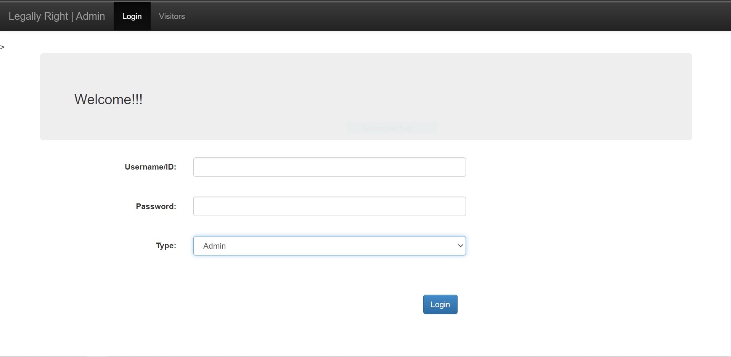

**Register lawyer :**

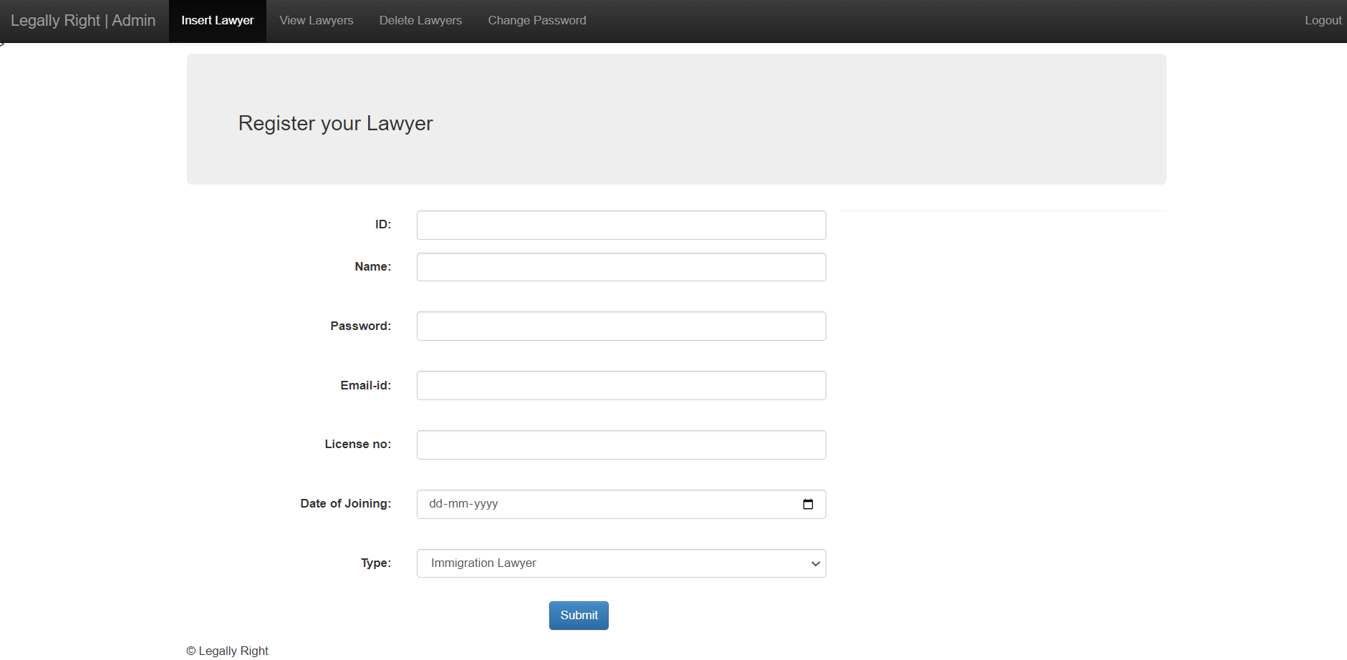

**VIEW LAWYER**

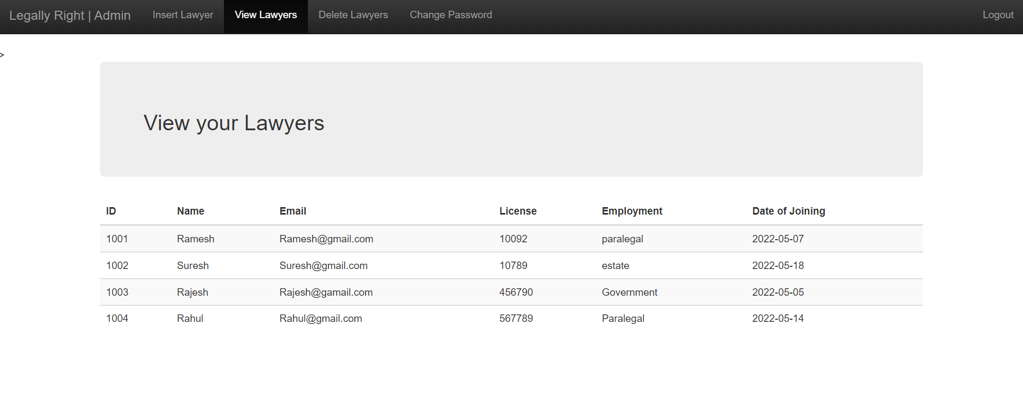

**DELETE LAWYER**

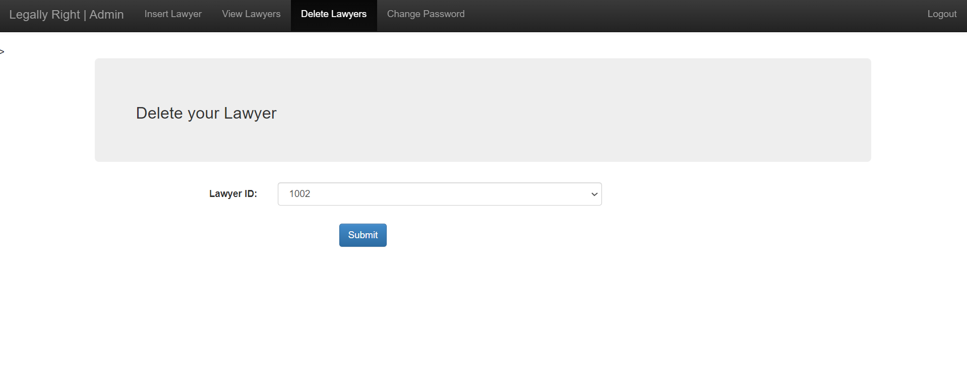

**CHANGE PASSWORD**

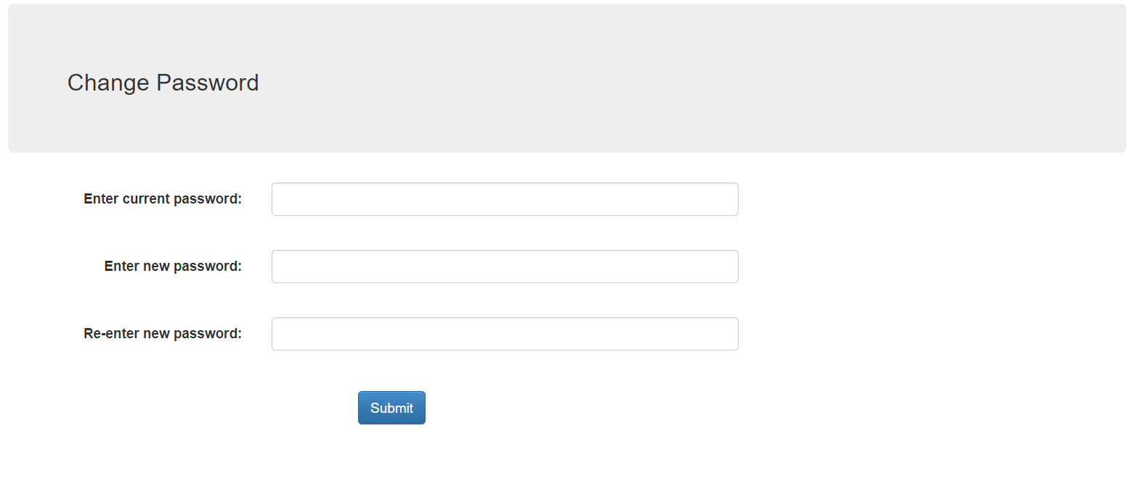

**LAWYER PAGE :**

**HOME PAGE :**

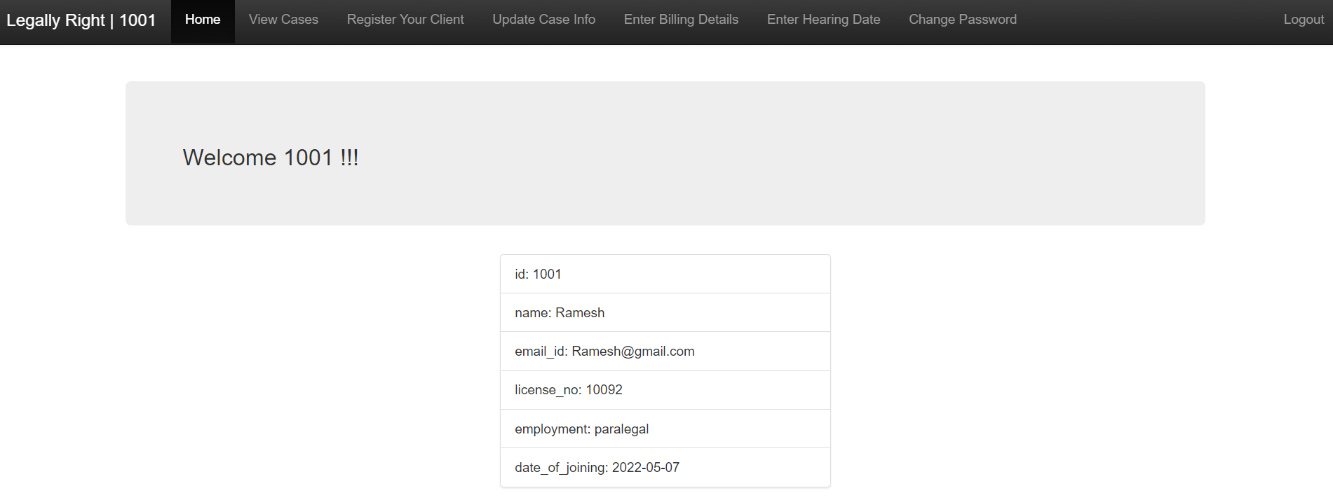

**REGISTER CASE :**

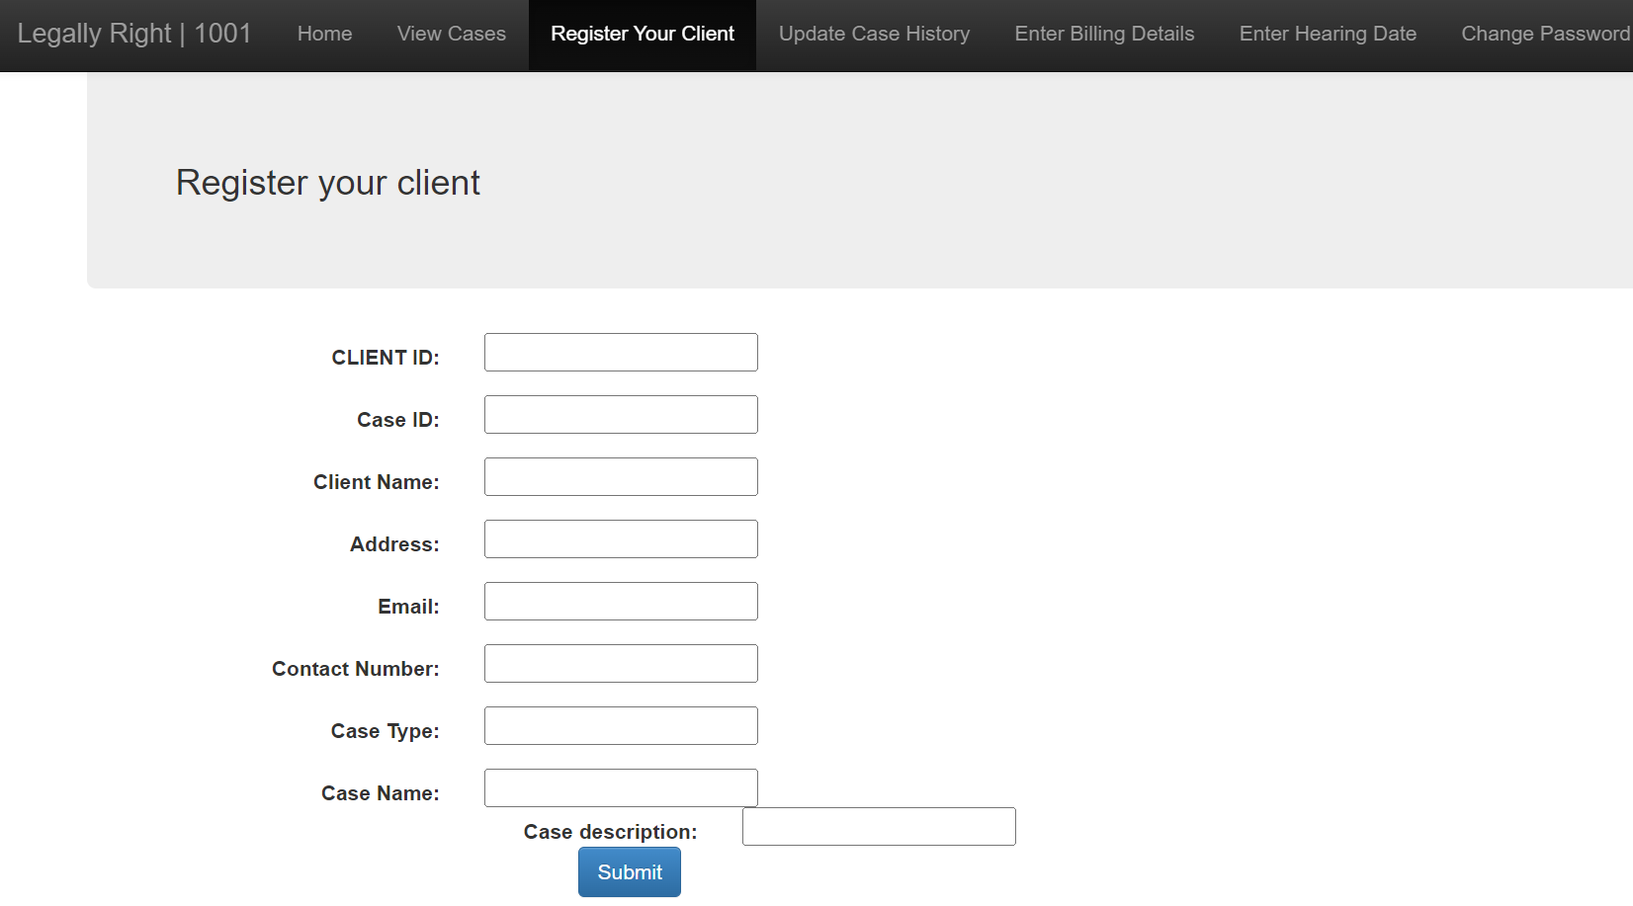

**UPDATE CASE :**

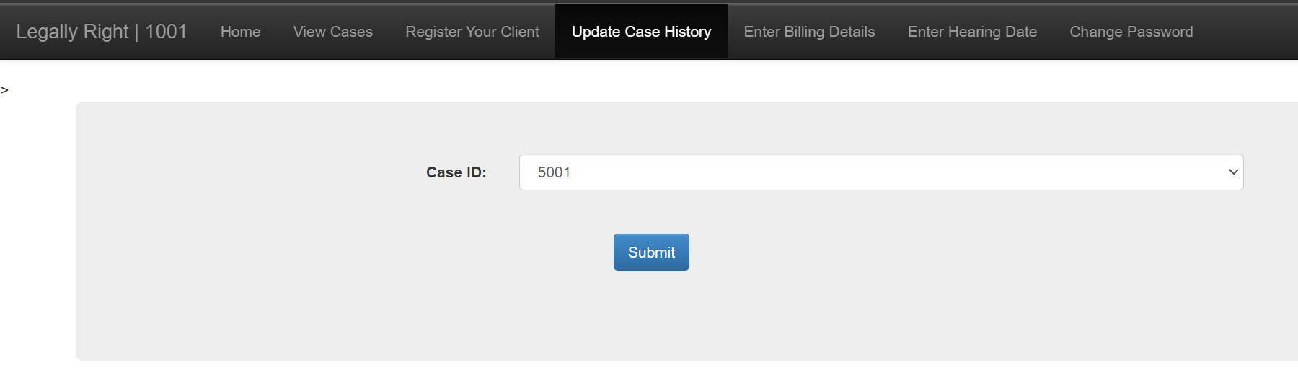

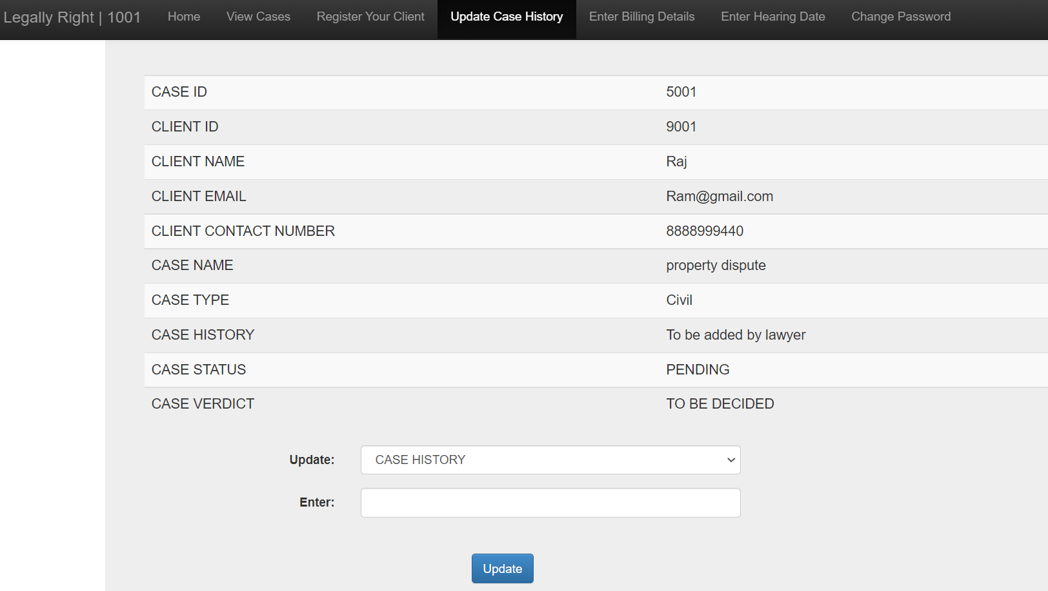

**ENTER BILLING**

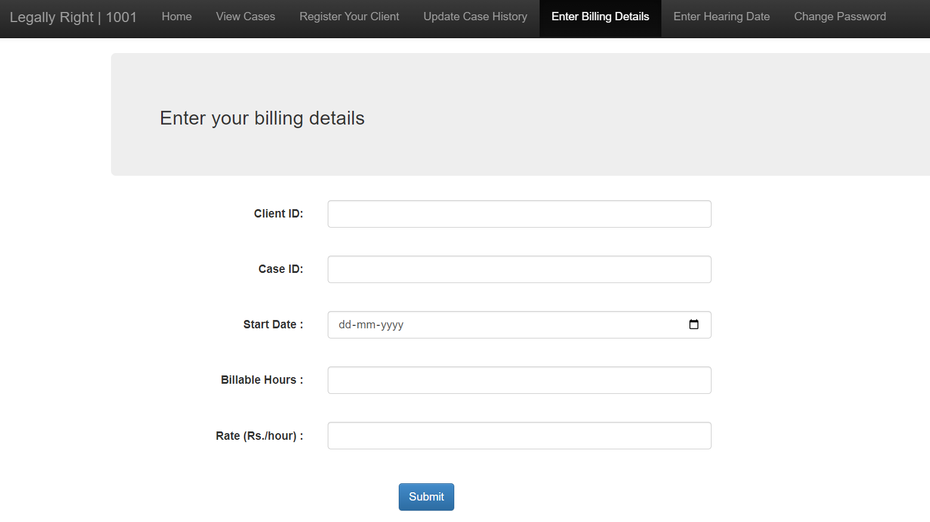**SET HEARING**

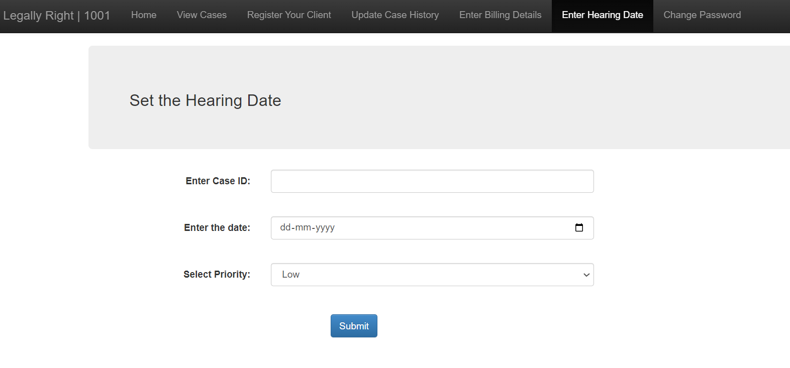

**View cases**

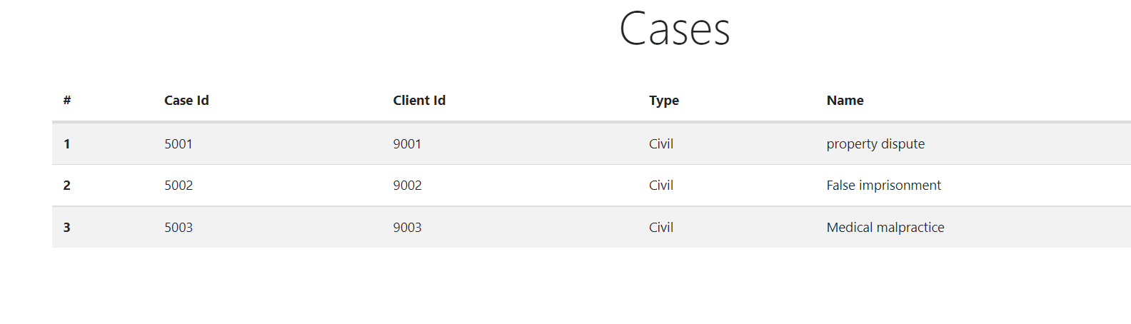

**Client page :**

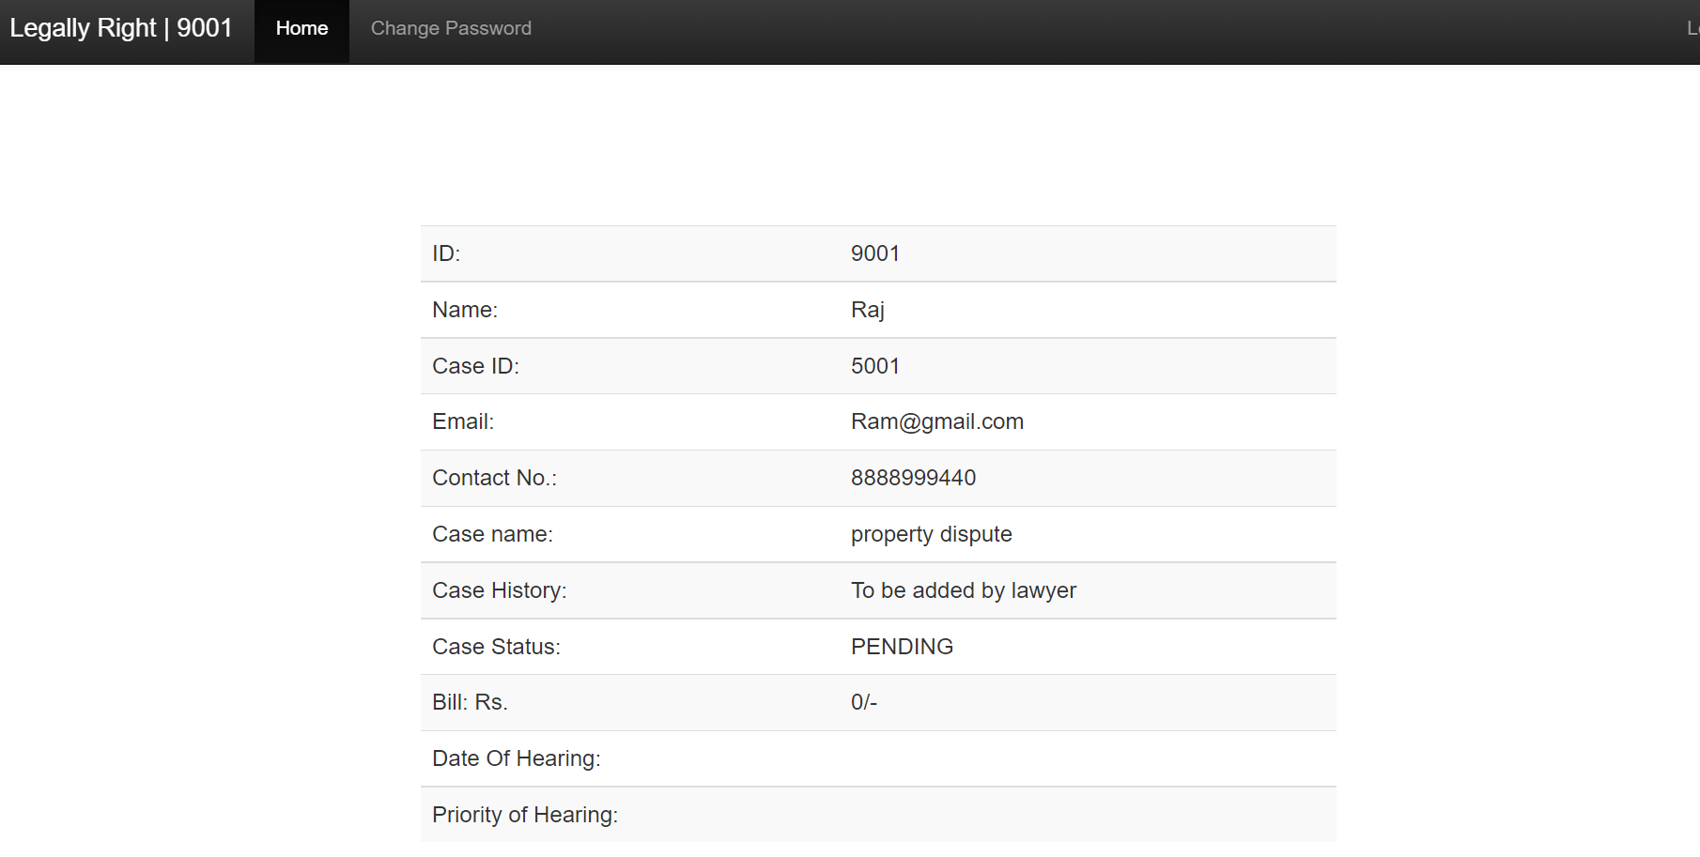

**CONCLUSION**

We have developed a web-based based application to control and allow complete registration of all court case which are related to the court by the domain lawyer who can register, update, delete and view cases. The client need not go and search for lawyers , clients can directly register their case and contact them from where they are. The flow of information provides communication and notification between the lawyer and client, in which the client or public can access status of a case online. We did our best so that this project meets the stated aim and looking back at the aim it can be seen that the project has been completed given that it has met the aim. This project has helped us learn how to work effectively as a team. This project has made us learn about the real life implementation of what we have studied. Though the main objectives of this project have been achieved we feel more additions can be made to the application. In future we plan to integrate other module onto the application thus the e-judge. We plan to create a platform that will send notification to client of their case , add judges to view case and provide an judgement via online .We also plan to rate the lawyers based on their previous cases victory and also the availability of lawyer , so that the client can choose his / her lawyer .

**REFERENCE**

**1.** Architects, I., 2017. The Seven Phases of the System-Development Life Cycle. [Online]

Available at: https://www.innovativearchitects.com/KnowledgeCenter/basic-

ITsystems/system-development-life-cycle.aspx [Accessed 13 02 2017].

**2.** B., L., 2002. Courts of the future’ Law and Information Technology. p. 225–238.

**3.** Beal, V., 2017. Entity-Relationship Diagram (model). [Online]

Available at: http://www.webopedia.com/TERM/E/entity_relationship_diagram.html

[Accessed 10 May 2017].

Bockweg, J. M. G. a. G., 2012. Insights to Building a Successful E-Filing Case

**4.** Management Service: U.S.. International Journal For Court Administration, pp. 1-9.

**5.** Chrisphine, M. K., 2012. Mbugua_Electronic case management system.pdf. [Online]

Available at:

http://erepository.uonbi.ac.ke/xmlui/bitstream/handle/11295/10911/Mbugua_Electronic%

20case%20management%20system.pdf?sequence=4&isAllowed=y [Accessed 24

October 2016].

**6.** Christian, 2009. The seven phases of the systems development life cycle. [Online]

Available at: http://petersheehan.blogspot.com/2009/01/seven-phases-of-

systemsdevelopment_11.html [Accessed 13 02 2017].

**7.** Dickson, O. B., 2015. The Structure and Jurisdiction of Court the Courts. [Online]

Available at:

https://www.academia.edu/12694626/THE_STRUCTURE_AND_JURISDICTION_OF_

THE_COURTS

[Accessed 27 October 2016].